**WEB API**

Giris qapisi, giris kartidir.

Bir platforma bagli deyil webden de, desktopdan da, mobiledan da sorgu gele biler.

Istenile sorgu gelir ve biz MVC controllerde action metodu tapir (db den data getire biler, service emeliyaati yerine yetire biler ve.s) ve isini gorur.

Data qaytarir.

Json ola biler, XML ola biler, ve yaxud her hansi sexsi, custom format ola biler.

Ustunlukleri:

MVC e gore daha portable dir.

Cunki istenilen platformdan sorgu gondere bilerik.

Isleme qaydasi:

Platformlardan Http request gelir ve ona Http Response (cavab) qayidir. (90% return tipi json olur)

Http protocol uzerinden isleyir.

Restful and soap adli web service tipleri var.

RESTful API and SOAP API are two different types of web services used for communication between different software applications.

RESTful API (Representational State Transfer) is an architectural style for creating web services. It uses HTTP protocols such as GET, POST, PUT, and DELETE to communicate between client and server. RESTful APIs rely on resources, which are identified by URIs (Uniform Resource Identifiers) and can be manipulated using standard HTTP methods. The data sent and received by RESTful APIs is usually in JSON or XML format. RESTful APIs are widely used for building scalable and lightweight applications and are often used in mobile and web applications.

SOAP API (Simple Object Access Protocol) is a protocol for exchanging structured information between applications over the internet. SOAP uses XML to encode the messages sent and received and typically uses HTTP or HTTPS for communication. SOAP APIs are typically more complex than RESTful APIs, but offer more features, such as built-in error handling, transaction support, and standardized security protocols. SOAP APIs are commonly used in enterprise applications where reliability and security are important.

In summary, RESTful APIs are lightweight, scalable, and flexible, while SOAP APIs are more complex and offer more features, but can be slower and less flexible. The choice between RESTful and SOAP API depends on the specific needs of the application and the level of complexity required for the data exchange.

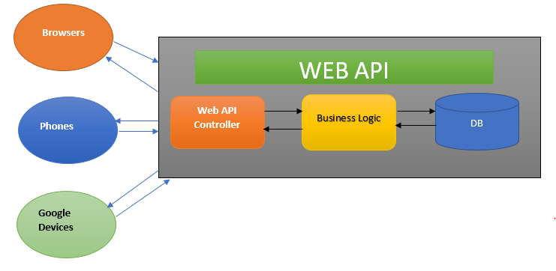

API da return ederken lazimsiz propertyleri gondermek sorgu qayitmasinda data coxluguna gore gecikmeye sebe ola biler. Buna fore de DTO (data-transfer-object) lar dan istifade etmek lazimdir. DTO da lazim olan property ler yazilir. Bu Encapsulation qaydalarina gore beledir.

